**Project Documentation – Automaton Machine (RE – NFA – DFA – CFG)**

**RecM- Regular Expression Combo Machine**

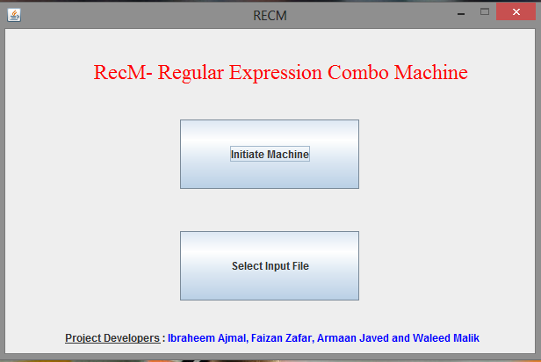

As per our requirement, this executable takes a path of input file as an input and then we can initiate the convertor.

Step 1: Select the input file

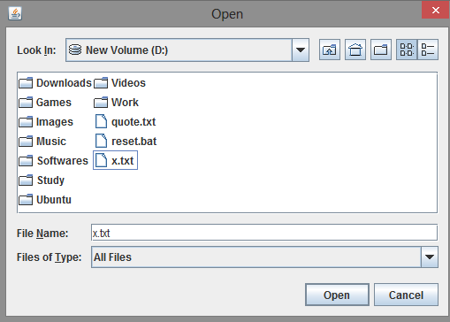

Step 2: Initiate Machine

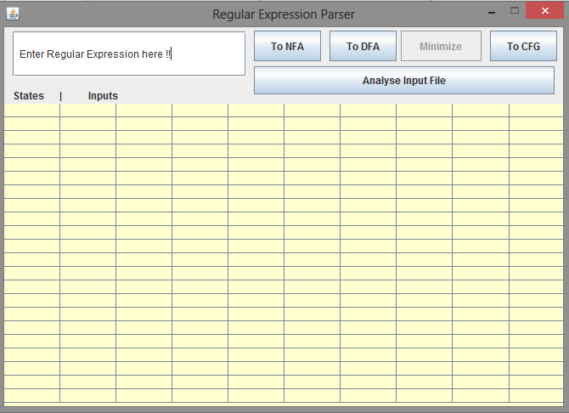

Step 3: Enter regular expression and Convert to NFA (Input: (a+b)*x|z* )

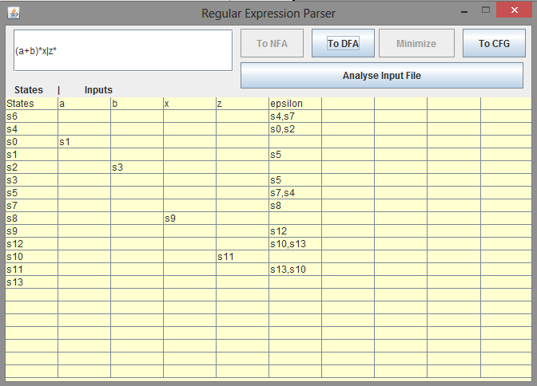

Step 4: Click “To DFA” button and it will output minimized DFA output

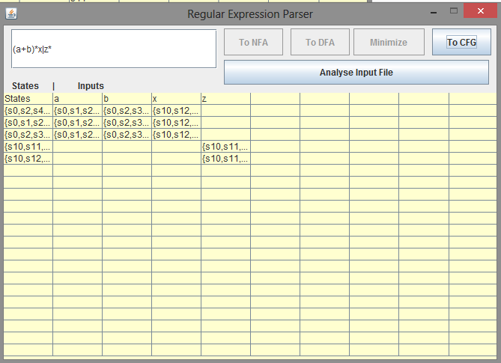

Step 5: Convert it to CFG

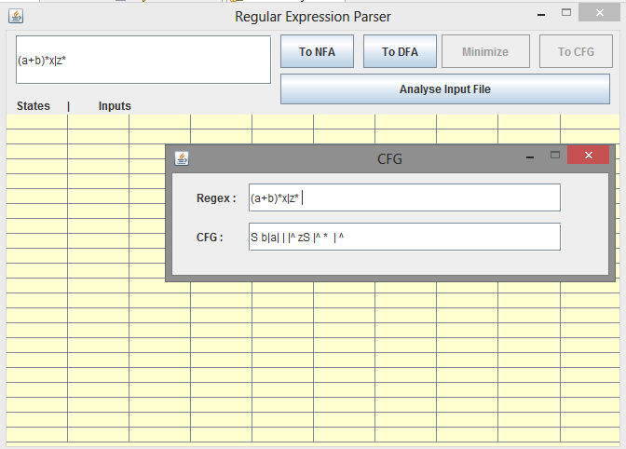

Step 6: Analyze Input file for (abcd+abdf)

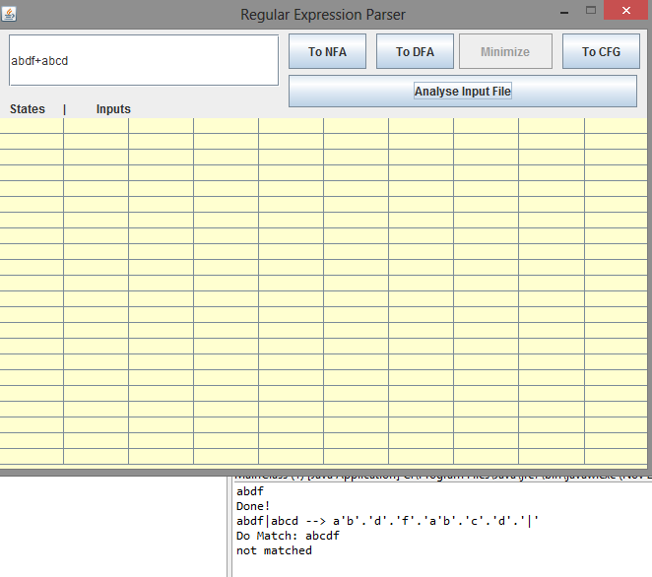

Output Check :

